St. Stephen Lutheran Church
248 Highland Road East, Kitchener, Ontario
Email: office@ststephenchurch.ca
Phone: 519-744-2521
Email: office@ststephenchurch.ca

March News 2024
Stay Awake

“Could you not stay awake with me one hour?” Jesus asks the sleeping disciples in the Garden of Gethsemane. (Luke 22:46) Worn out by the pace of events, unable to bear Jesus predictions of what was to come, they simply fell asleep. And he needed them to stay awake.

But why? Jesus is the strong one, the one who reveals the nature of God, the leader and teacher. Surely, he doesn’t feel fear as we do, or need to lean on others?

“Stay awake.” Keeping company with Jesus comes down to this: finding a way of living in this world that allows us to stay awake to its reality, and to the reality of God-with-us. In this Lent-Easter season, this is still the response Jesus asks of us.

But how can we stay awake to God, when on the outside we are surrounded by so much noise, so much information, so many people needing our attention? And when we have so much inner noise - anxiety about the future, unprocessed events, decisions and choices in the making?

What would it be like to be really awake? To see the world’s pain and its beauty? To experience all our experiences?

“Stay awake with me and pray.” Here is the important part. If Jesus is with us we can bear to see and hear reality. To stay awake with Jesus, and to pray, is to enter into the kind of companionship that he longed for his disciples to experience. To be completely alert to life’s realities, but to allow that way of being present to be a prayer - for peace, for reconciliation, to justice, for healing, for living out of Christ’s way on earth.

As we listen again to the stories of this holy season, may we find in them an invitation to all that is happening in our lives and in our world, and to keep company with Jesus Christ. Prayer brings the two together.

I invite you to participate in all of the opportunities to stay awake with Christ during this Holy Week and Easter season. Stay awake on Palm Sunday to learn about the servant-king. Stay awake on Maundy Thursday and learn from Jesus why the Last Supper is important for our lives. Stay awake on Good Friday and learn why Jesus’ suffering and death was crucial to our salvation (to our being made holy). Stay awake on Easter Sunday as we visit the empty tomb and sing with joy in the knowledge that Christ is risen to reconcile us (to make us re-connected) with God.

“Stay awake with me and pray.”

I pray that your Lenten Journey will come to fulfilment at the empty tomb on Easter Sunday morning. May God bless you in your prayer time as you stay awake with Jesus.

In Christ’s service

Pastor Hans

Agape Meal
This year for Maundy Thursday you will have the opportunity to experience something new. We will be serving an Agape Meal on Thursday beginning at 5:30 p.m. What is an Agape Meal you may ask?

Agape is one of the five words that are translated in English as love. In the case of Agape, its unconditional love, similar to the love we receive on a continual basis from God, so, quite often this is referred to as a Love Feast. The Agape Meal originated in the early church and was a time of fellowship for the early believers. The earliest reference to a meal that could be referred to as Agape is in Paul’s first letter to the church in Corinth. Many New Testament scholars believe that the believers in Corinth met in the evening and shared a common meal which also included sacramental action over bread and wine. The reference in Corinthians indicates that it was a full meal with the participants bringing their own food but eating in a common room. Throughout the years the Agape meal has had a place in the shadows of church life. After the Reformation there was a move among many groups of Christians to try and return to the practices of the New Testament Church.

While many denominations have differing traditions around the Agape Meal, the Methodist Church made a regular practice of holding Agape Meals, believing they were also a “Means of Grace.” The Methodist Church also included a full liturgy which involved prayers, hymns a sung grace, collection for the poor, address by the presiding minister, and circulation of bread and the “loving-cup.,” and also had references to foot-washing.

Over the past number of years our Protestant churches have tried very hard not to misappropriate the traditions of other denominations or cultures. An Agape Meal, however, is part of our rich heritage which we can celebrate together.

I invite you to join us on Maundy Thursday, 28 March 2024 for an Agape Meal. The Community Life Committee will provide the “meat and potatoes” and you are invited to bring salads and desserts to share. Our Agape Meal will also include a laid-out liturgy with hymns, readings, prayers, hand-washing, and Holy Communion. Please join us for this opportunity to share food and fellowship together as we hear the events that occurred on the night of “The Last Supper.” Please note that the only wine served will be during Holy Communion.

Good Friday
On Good Friday, we remember the crucifixion of our Lord and Saviour Jesus Christ. Our worship service draws on two traditions from the Holy Week observance. The Tenebrae service dates back to at least the eighth century. Tenebrae means ‘shadows’ in Latin and the Tenebrae service is a time of commemorating the suffering and death of Jesus. In many churches, candles are extinguished during the service as a sign of the passage from light to darkness. That will happen in our service as well.

The service focuses on the question that Pilate asked the crowd after they chose Barabbas over Jesus. He asked them this question: What shall I do, then, with Jesus who is called Christ? Many key players in the Passion Story gave their answers to that question in one way or another, and today we want to examine those answers and ultimately ask the same question of ourselves: What shall I do, then, with Jesus who is called the Christ?

Please join us as we worship on Good Friday. Our service begins at 10:00 am.

Treasurer’s Report

The Financial reports for 2023 and the Budget for 2024 will be available in the next few weeks. They will be discussed at the Annual General meeting however if you have specific questions or wish some clarification before that please contact me.
For January, our donations were less than the monthly expenses so we will start off the year with a deficit. This does not consider that the insurance payment of over $ 11,000 was issued in January.
I recently received some comparisons. The number of families financially contributing to St. Stephen has decreased by 25% since 2020. As we all know the expenses have risen since then so to maintain operations it makes sense that each of us needs to contributor more. The council tires hard to curtail expenses but we have little control over such things as utilities, repairs etc.
If you would like to assist St. Stephen financially the website outlines methods to support us. You can mail in or drop off a cheque or send an e-transfer to the church funds at office@ststephenchurch.ca

Treasurer
Brian Burchatzki
548 288-7215

Community Life Team Update
On Sunday Feb 18th we prepared and served a Valentine’s Lunch for approximately 60 people. A fun event filled with delicious food, fun games, and as always great fellowship. The games included each table singing a song with love in it. Enthusiastic song choices entertained us including “Skinnamarink” by Sharon Lois & Bram. A trivia game about all things related to Valentine’s Day was led by Reina. What a great variety of questions to test our knowledge of this special day. Congratulations to the winner, Dave Brown. Also, congratulations to Pastor Hans for guessing the closest number of candies in the jar. We celebrated the longest dating & married couple Wilma & David Peirson (64 years) and shortest dating and married couple Betty & Bruce Lackenbauer (33 years). The lunch included celebrating February birthdays. Thank you to Bob Cruickshank for helping to sponsor the cake.

Upcoming Events:
- Lenten Soup supers continue each Wednesday night. Please sign up to bring soup or dessert.
- Maundy Thursday Agape Meal. Thursday March 28th starting at 5:30pm. A sign-up sheet will be posted. Stripping of the Altar in the sanctuary following dinner.
- Easter Sunday Breakfast. A Continental Type breakfast will be served at 8:30am.
- Saturday Night Games Night – the next games night will be Saturday March 23 at 7pm.
- Card Making Afternoon – Back by popular demand -Date Thursday April 11th at 1pm. Cost $15pp. Please bring scissors, tweezers, liquid glue, and a ruler.
- Bingemans Lunch and Show. We have reserved 20 seats for the ‘Material Girls’ show on Wednesday April 25th. The cost this year is $72.95pp. A sign-up sheet will be posted.
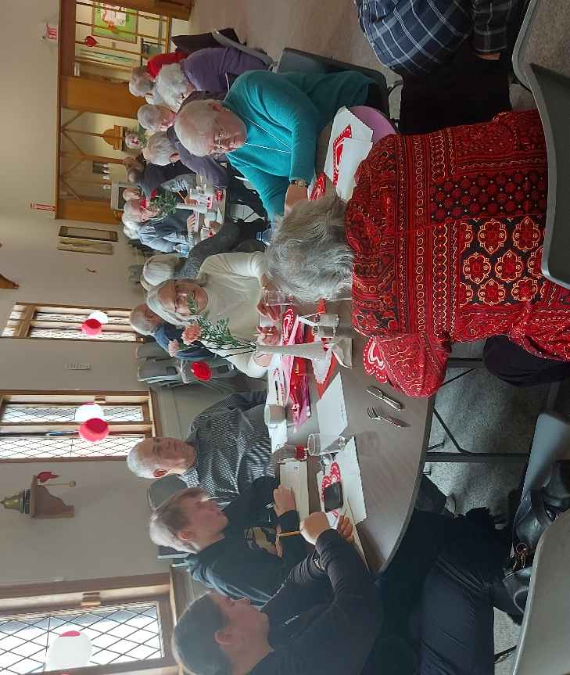
Your Community Life Team.

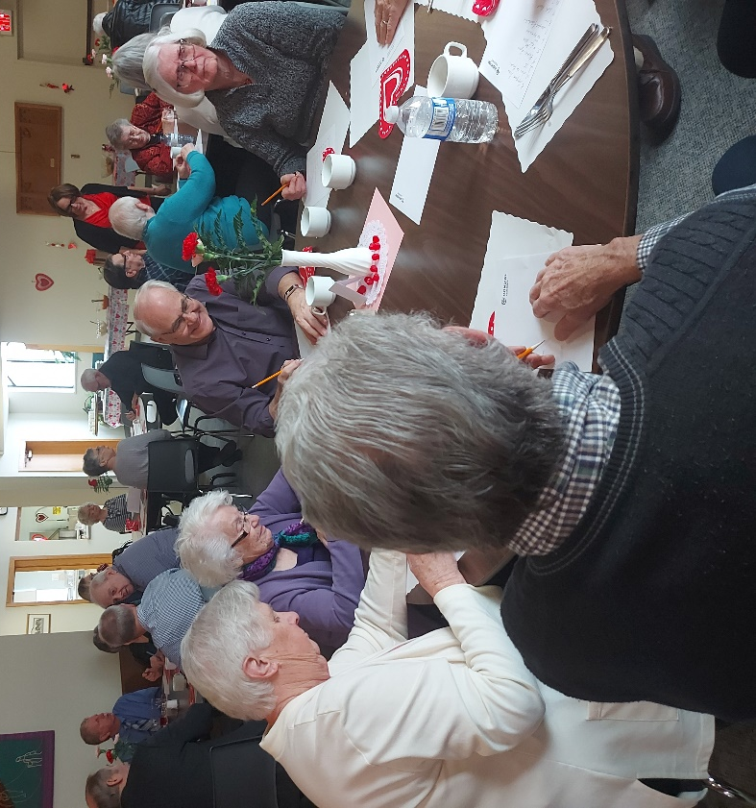

ELW News
The ELW will meet on Monday, March 18 at 1:30 to assemble the layettes for CAMC. If you are purchasing items for the layettes, please have them at the church by Sunday, March 17. Thank you for participating.

Music Notes
The choir is busy preparing for Palm Sunday, Good Friday, and Easter Sunday. We hope you will support and enjoy the choir's contributions to the worship service.
At the beginning of March, Menno Singers is presenting a concert of Lenten inspired music - At the Foot of the Cross. It features Ben Bolt Martin on the cello. This concert is March 9, 7:30pm at Trillium Lutheran Church.
Holden Evening Prayer services continue through Lent in preparation for Easter celebrations.
We hope that the music offerings help us to focus on the meaning of the season.
Blessings,
Elizabeth Hackett
Church Musician

Worship and Music
Small Symbols Mean A Lot
I recently worshipped with a United Church congregation in Cobourg. A youth leadership organization that I support has met there three times previously, over the last five years. I was getting volunteers to help out during the service when I mentioned that we needed someone to light candles. This congregation has two candles on the altar that they light as part of the call to worship. A white one that they call the Christ Candle and one that is set in a jar of multicoloured bands of sand that they call the Affirmation Candle. One of the youth immediately asked, “Do you mean the Gay Candle?” This is a youth who identifies as gay.
Remember that this person had been in this church no more than three times over five years, and they remembered a symbolic action that had taken no more than a few seconds each time. That one little act had been a clear and memorable message to this youth that they were welcome in this space.
It made me think about the messages that we send out. What messages do we send that a stranger would remember several years later? How can we be intentional about the messages that we send?
As we look to the future and consider what we would like our community of faith to be, I think that it is worth considering these questions.
Submitted by,
Jan Hansen
Worship and Music Team Chair

My Perspective- What’s New? March 2024
What’s new in March? Spring, homeowner taxes? Oh, wait. Those last two make regular appearances, one when Mother Nature deems it’s time, and the second, as regular as all the bills that come in.
By the time March comes, I’m ready for more sunshine. Truth be told, the sun that shines outside, as I write this, is most welcome. I got out for a walk today to enjoy it. While our snow piles at the end of our driveway have only happened a couple of times this winter, it’s been milder overall. Still the sunshine got lost in the clouds many days.
March is as good a month as any to consider our outdoor environment and how we treat nature. We can start with a garden, for those who have a piece of land to call their own. I enjoy being in the garden, mind you, not for miles of market garden rows. Still it’s satisfying to grow some of our own food, and share it.
In that vein, I saw an ad on Marketplace today for raised garden beds, made of untreated wood, right in our twin cities. It’s important to have something that will last and not leach harmful chemicals into the soil where we intend grow food.
We have two raised beds that my husband built nine years ago. Ours are showing signs of wood rot, and will eventually need to be replaced with something else. So I was curious if the ones advertised would be a good replacement. The fellow replied that he delivers them too.
I will assess our boxes once the snow is gone.
Our grandkids help with the planting each year, the older ones able to help the younger ones. Then they get to water the garden and eat some of the produce as the plants produce. Besides most of them like having their hands in the dirt. One for sure. Plus, they enjoy being together.
For those with no piece of land, or cannot garden anymore, there are things you can do too, from recycling to composting. Those help everyone. Let’s think on other ideas until the sun warms us up a bit more.
We are stewards of the land. How we use it matters a great deal.
For entire post with link to my blog
https://www.storygal.ca/2024/02/21/whats-new-in-march/ -Carolyn Wilker

